Internet and politics in review: An analysis on the profile of Brazilian papers

presented between 2000 and 2011

Rafael Cardoso Sampaio
PhD Candidate of Universidade Federal da Bahia (Brazil) and visiting scholar of University of Leeds. He has a scholarship from CNPq and is associate researcher of Centro de Estudos Avançados em Governo Eletrônico e Democracia Digital Facom-UFBA [Center of Advanced Studies on e-government and e-democracy]. He is also consultant of World Bank and of Digital Office from State government of Rio Grande do Sul, Brazil. He researches on digital democracy, e-government, e-partipation, online deliberation and specifically on e-participatory budgeting. cardososampaio@gmail.com

Rachel Callai Bragatto.
PhD Candidate of Universidade Federal do Paraná (Brazil) and visiting scholar of University of California (USA). She has a scholarship from Reuni/Capes and is associate researcher of Instituições, Comportamento Político e Novas Tecnologias [Institutions, political behaviour and new Technologies]. She researches on digital democracy, e-partipation, online activism, civil society movements. rachelbragatto@gmail.com

Maria Alejandra Nicolás
PhD Candidate of Universidade Federal do Paraná (Brazil). She has a scholarship from Reuni/Capes and is associate researcher of Instituições, Comportamento Político e Novas Tecnologias [Institutions, political behaviour and new Technologies]. And Política, Informação e Novas Tecnologias [Politics, Information and new technologies]. She researches on digital democracy, e-government, e-parliament, e-partipation and online deliberation. alejandranicolas@gmail.com

Internet and politics in review: An analysis on the profile of Brazilian papers

presented between 2000 and 2011

Abstract: This article focuses on the appropriation of the subject "Internet and Politics" by Brazilian Social Sciences. For this, we analysed 299 papers presented at 11 conferences in the areas of Sociology, Political Science and Social Communication from 2000 to 2011 in Brazil. The methodology was based on a content analysis with the intention of showing the main authors, research centres, political and technological objects, theoretical approaches, methods, techniques andcoverage areas of the papers presented in each of these conferences. On the one hand, the results indicate a number of concentrations and differences regarding authors, institutions and geographical regions involved in the research. On the other hand, there is evidence of greater consolidation and ripening of the area, which is focused on more specific objects and presents a growth of empirical studies.

Key words: Internet and Politics. Digital Democracy. Academic Research. Political Communication. Brazil.

Rafael Cardoso Sampaio
PhD Candidate of Universidade Federal da Bahia (Brazil) and visiting scholar of University of Leeds. He has a scholarship from CNPq and is associate researcher of Centro de Estudos Avançados em Governo Eletrônico e Democracia Digital Facom-UFBA [Center of Advanced Studies on e-government and e-democracy]. He is also consultant of World Bank and of Digital Office from State government of Rio Grande do Sul, Brazil. He researches on digital democracy, e-government, e-partipation, online deliberation and specifically on e-participatory budgeting. cardososampaio@gmail.com

Rachel Callai Bragatto.
PhD Candidate of Universidade Federal do Paraná (Brazil) and visiting scholar of University of California (USA). She has a scholarship from Reuni/Capes and is associate researcher of Instituições, Comportamento Político e Novas Tecnologias [Institutions, political behaviour and new Technologies]. She researches on digital democracy, e-partipation, online activism, civil society movements. rachelbragatto@gmail.com

Maria Alejandra Nicolás
PhD Candidate of Universidade Federal do Paraná (Brazil). She has a scholarship from Reuni/Capes and is associate researcher of Instituições, Comportamento Político e Novas Tecnologias [Institutions, political behaviour and new Technologies]. And Política, Informação e Novas Tecnologias [Politics, Information and new technologies]. She researches on digital democracy, e-government, e-parliament, e-partipation and online deliberation. alejandranicolas@gmail.com

INTRODUCTION

Since the advent of the Internet in 1969 and mainly after the invention of the World Wide Web in 1989, we have observed both the growth and the deepening of debates about the impact of the new media on the democratic system. Such studies are based on reflections about the possibility of the Internet changing the democratic experience, and because of the technological characteristics of the new medium other elements would be brought into the debate.
Thus, there are numerous studies on noble political topics addressed in light of the changes related to the insertion of Information and Communication Technologies (ICTs) in social dynamics. Indeed, in Western countries, the use of the Internet by the most diverse types of political actors and institutions that participate in political systems has been object of a systematic and empirically oriented analysis, especially in Anglo-Saxon nations (Medaglia, 2012; Sæbø et al, 2008; Susha & Grönlund, 2012).
Specifically in Brazil, there is also a broad and continuous level of publication in this field. There are studies on the opportunities for participation offered by the State to the civil sphere (Braga et al, 2009; Marques, 2010); online campaigns and impact of the Internet on electoral disputes (Aggio, 2010); debates about the effect of the Internet on party organization (Albuquerque &Martins, 2010); issues related to the use of blogs and new political practices (Penteado et al, 2009); reflections on the potential of the Internet as a public sphere and for online deliberation (Sampaio et al, 2010); studies on the uses of the new media by civil society organizations (Maia, 2011); the relation between the new media and social inequality (Moraes et al, 2009) among others.
However, although the Brazilian bibliography is extensive, initiatives to map Brazilian research that seek to apprehend data on academic publication are still rare. Except for the efforts made by Amaral and Montardo (2011), Araújo (2011) and Bragatto and Nicolas (2011), we cannot find other attempts that would enable a systematic recognition of the state of the art, that is, of major universities, authors, approaches, themes and objects that have guided research in the field in Brazil.
In this sense, the purpose of this paper is to present the results of our research on the appropriation of the theme "Internet and Politics" as an object of study by Brazilian Social Sciences, especially by Sociology, Political Science and Communication. Therefore, we analysed the papers presented on the subject at some of the major conferences held in Brazil from 2000 to 2011.
In order to present our research, we organized this article as follows: (1) first, we will do a short review of the studies on Internet and Politics; (2) secondly, we will present a summary of the methodology employed; (3) thirdly, we will examine some empirical evidence of the research; (4) and finally, we will close the paper with some considerations and notes about a research agenda.

INTERNET AND POLITICS

In the same way when the insertion of the telegraph, radio and television happened, the discussions on the impact of the Internet on political relations between citizen and State were accompanied by what might be called the discourse of technological determinism - rhetoric about radical changes that would occur based on the social and political appropriation of new technological artefacts. Throughout history, there existed the idea that new technologies would promote, invigorate or cause ruptures in the democratic system (Wright, 2006).
As pointed out by Coleman (1999), the debate during this period occurred by means of vague terms, lacking clarity about which key question should drive the research. But with the progress of the analysis, the initial question "what can the Internet do for democracy" is being replaced by questions about how the different media, channels and digital tools that form the Internet can be used by individuals, organizations and institutions involved or interested in the political system to enhance democratic values​​. To this we can add several variables such as socio economic and cultural factors, party ideology, level of Internet access, digital literacy, etc. Likewise, the willingness of political representatives to implement or accept such innovations and the motivation of citizens to create or seize such opportunities become study subjects (Chadwick, 2011; Gomes, 2011; Marques, 2010; Medaglia, 2012; Sæbø et al, 2008).
In this sense, a cleavage that helps the present study is the one that refers to the affiliation of the works with the social or institutional strand (Gomes, 2007). As object of the former, there are the implications of the new media in civic engagement, public sphere, political deliberation and its relation with social capital. In common, there is the concern with the political formation and political skills of citizenship in cyberspace. That is, how the Internet can provide suitable places for the formulation of preferences, strengthening of links between groups with the same interests, organization of social demands and ripening of political and ideological positions.
The “institutional view” will address three things:

a) the study on the digital conformation of the democratic institutions in a strict sense (digital cities and governments, online parliaments) or in a broad sense (online political parties) b) the institutional initiatives in the vector that goes from State to citizens (such as the provision of online public services and e-government), c) institutional initiatives in the citizen to State vector (opportunities for participation or offering of inputs by the citizenry in the form of votes, responses to surveys, budget decisions or suggestions, record and discussion of opinions in electronic forums, etc.) (Gomes, 2007: 11).

The considerations here are of a more structural order, since they relate to the organization of the environment and democratic dynamics and, consequently, the link between the institutions of the democratic State and the citizenry.
However, beyond the distinction between institutional and social strand, normative issues relating to the models of democracy emerge - a common background in the analyses. Just as different views of democracy were always present in the discussions on political theory, the same is true with respect to the researches that focus on the impact of the Internet on the democratic experience. Liberals emphasize the need for greater visibility and accountability. Supporters of strong democracy call for the conformation of spaces in which citizens can express their will directly. Deliberative Democracy theorists emphasize the importance of exchanging reasons in public and the theme of the public sphere (Dahlberg, 2011; Gomes, 2007).
Similarly, the evaluation of the effects also suffers variation and part of the literature has characterized the studies according to three general hypotheses: mobilization, reinforcement and normalization. Briefly, the first postulates that new tecnhnologies pontentially can mobilize citizens to participate into political activities, increasing the number of people involved; the second suggests that ICTs are utilized only by those people already interested and engaged in politics; and finally the third believes that the internet make few if any difference in short term, because political actors and institutions utilize the ICTs for their own agenda and needs (Wright, 2006).
On the other hand, the reinforcement hypothesis is based on the understanding that the Internet would be used only by citizens that are already active, interested and participant. According to Norris (2003), despite the democratic gains in the supply of new tools to already active citizens, it is not clear how this would activate the engagement of individuals who are uninterested in politics. Lastly, the normalization theory states that, even if there are short term political impacts by the use of the Internet, the situation tends to normalize in the long run. For the theorists who defend this point of view, institutions and actors in the formal political system tend to initially resist to the changes brought by new media and, later, to adapt these tools and resources to their own routines and agendas, generating little or no impact on the formal political system (Muhlberger, 2004).
Given the above theoretical assumptions, which are not exhausted in the authors’ nor in the ideas mentioned, in the next section we move on to the presentation of the methodology for the analysis of the papers presented in conferences in Brazil.

METHODOLOGY

Our methodology is structured to construct variables that allow a comparative analysis of the papers about Internet and Politics mapped in the selected conferences. Similar surveys have already been conducted previously. Internationally, we highlight the work of Kræmmergaard and Schlichter (2011), which listed 450 articles on e-government from 2000 to 2009, of Sæbø et al (2008), which found 131 articles on e-participation published up to the year 2006 and of Medaglia (2012), which, in continuity to the research of Sæbø and team, analysed 123 articles on e-participation in the period of 2006 to 2011.
In Brazil, as mentioned before, we found only three studies focused on mapping literature related to Internet and politics. First, Amaral and Montardo (2011) made an analysis of all the papers presented in the Cyberculture sessions at Intercom Meeting from 2001 to 2010 (N=443) and identified 13 major themes in the studies. Secondly, Araújo (2011) listed the Brazilian works in the area of ​cyber-activism from 2000 to 2010 (N=22) and classified them according to the publication period, the area and institution of the authors, the research object and bibliographical sources. And, finally, Bragatto and Nicolas (2011) mapped studies presented at four Brazilian conferences between 2006 and 2010 (N=71) which were categorized according to themes, objects of study, types of approaches, methods and research techniques.
It is noteworthy that, in order to perform this research, there was an apparent need to define the concept of politics. We chose the broad concept of politics of Maia, "not only restricted to the world of governments and the function of defining votes by citizens, but one that also encompasses the processes of civic association, negotiation and conflict among subjects in day-to-day interactions"(2006, p.15).
Initially, it was necessary to separate political activity from acts of sociability to avoid grouping very disparate researches. Therefore, we considered two key questions. The first was the object of study and the second, the objective made explicit by the authors. The papers would only be included in the sample if its object and/or objective were directly related to political actors or political activities.
Regarding our sample, we considered the main conferences of Sociology, Political Science and Communication held in Brazilian territory. The period covered by the papers goes from 2000 to 2011. Besides believing that a decade of analysis leads us to more general conclusions and the monitoring of the field's trajectory, it is noteworthy that the first annals of conferences became available online in 2000.
We analysed 299 papers presented in 11 conferences. We checked every annals and proceedings available online. We used three progressive rules as follows: 1) initially we checked only the title and abstract, 2) if this was not sufficient, we would evaluate also the introduction and conclusion and, if there remained any doubts, 3) various parts of each paper were examined.
For the testing and subsequent refinement of the criteria, three pilot studies were conducted. In the first, thirty papers were analysed and the problems and difficulties were reported, which led to changes and improvements in the indicators. In the second pilot test, the application was remade with the thirty original papers and another thirty were added, but using the new categories created after the first pilot. Finally, the third test involved the application of the criteria in thirty papers that were different from the previous sixty. Again, changes were made to the spreadsheet, which thus reached its final form, as can be seen below.

- Conferences: we considered the seminars, conferences, meetings and symposia held in the country. We adopted certain criteria in this selection: the existence of a work group, area or session that included studies on the relation between the Internet and Communication, Sociology or Political Science; periodicity; nationwide coverage; possibility of participation of postgraduate students. Each paper was classified as to (1) name of the conference, (2) institution hosting the conference, (3) year of the conference, (4) name of the session.
- General characteristics of the paper: We collected information related to the name of the paper; if it has keywords or not; if so, the first three keywords and, lastly, the level of detail required for analysing: (1) abstract, (2) abstract, introduction and conclusion (3) various parts of the paper.
- Authors and Institutions: we included variables such as (1) name, which allows to check whether or not there is a concentration of authors in the sample; (2) the author's institution, seeking to notice if there are major research centres in the area; (3) Brazilian state of the institution; (4) title of the author; (5) area of ​​expertise (we considered the area of the author's last title); (6) if the author is a professor; (7) if so, at which institution; (8) whether the author belongs to a research group; (9) number of authors, and (10) in case there is more than one author, if it is an inter-institutional partnership, which could indicate a greater consolidation of the field.
- Type of strand: corresponds to the cleavage observed in the papers, if social or institutional. For the categorization, we used as reference the classification of Gomes (2007), as cited.
- Theoretical approach: at this point, the goal was to verify the text's main theoretical approach; however, there are a multitude of theoretical areas in the studies of the Internet and politics. Thus, we chose to create broader categories, that could summarize the main theoretical approaches in the area: (1) Transparency, (2) Information, (3) Participation, (4) Deliberation, (5) Engagement, (6) Digital inclusion, (7) Social capital and political culture, (8) Identity and citizenship, (9) Political and electoral strategy, (10) Accountability, (11) Representation, (12) Political economy (13) Other.

- Technological object: that is, the media or digital tool analysed by the paper in evaluation. We considered the following categories: (1) Discussion boards and chats, (2) Blogs, (3) Websites, (4) Social networks (Orkut, Facebook, Twitter etc.), (5) Wikis (Wikileaks, Wikipedia etc.), (6) Open source software, (7) Content share sites (YouTube, Flickr), (8) Internet, (9) Media, (10) Other. The categories "Internet" and "Media" were created after the first pilots of the analysis, because some papers (especially the theoretical ones) did not address specific technological objects.
- Political object: we chose categories that would be able to systematize the main points of attention of the studies on Internet and politics: (1) Communication policies, (2) Electoral campaigns, (3) Political parties, (4) Government (Executive, Legislative and Judiciary), (5) Social movements and civic organizations, (6) Non-organized civil sphere (“spontaneous” individuals and political movements), (7) Other.
- Methodological variables: we include in this item the variables that are related to the methodology issues of the papers. It consists of:
- type of approach: (a) Theoretical (b) Empirical;
- type of method: (a) Qualitative (b) Quantitative (c) Bibliographical. The classification results from the type of technique used in the researches;
- type of empirical technique: we sought to identify the main analytical techniques used by Brazilian researchers, namely: (1) Survey (2) Ethnography (3) Interview, (4) Discourse Analysis, (5) Content Analysis, (6) Mapping of networks, (7) Did not apply any of the prior techniques.
- use of statistical technique: first, we applied a dummy variable on the use or non-use of statistics, and then verified the type of statistic used. They are: (1) simple frequency, (2) descriptive statistics, (3) inferential statistics.

RESULTS

Altogether, we analysed 299 papers presented at eleven congresses in Brazilian territory. At the Meeting of the National Association of Post Graduation Programmes in Communication (Encontro da Associação Nacional dos Programas de Pós-Graduação em Comunicação – Compós) we listed 36 papers from 2000 to 2011 (representing 12.0% of the sample), excluding the years 2003 and 2004 because there was no paper on the subject. Regarding the Meeting of the National Association of Post Graduation in Social Sciences (Encontro da Associação Nacional de Pós-Graduação em Ciências Sociais – Anpocs), 27 papers (9,0%) were evaluated, from 2010 and 2011. Regarding the Meeting of the Brazilian Association of Researchers in Communication and Politics (Encontro da Associação Brasileira de Pesquisadores em Comunicação e Política – Compolítica), we found 52 papers (17.4%) from the years 2006, 2007, 2009 and 2011 (covering, therefore, all of the meetings of the association). At the Brazilian Congress of Sociology (Congresso Brasileiro de Sociologia – CBS), there were 10 papers (3.0%), involving the years 2005, 2009 and 2011. At the Meeting of the Brazilian Association of Political Science (Encontro da Associação Brasileira de Ciência Política – ABCP), we analysed 13 papers (4.3%) from the years 2008 and 2010. At the National Seminar of Sociology & Politics (Seminário Nacional de Sociologia & Política – UFPR), there were 24 papers (8.0%), covering the years 2009, 2010 and 2011. At the Brazilian Forum of Political Science (Fórum Brasileiro de Ciência Política – Ufscar) there were five papers (1.7%) from 2011. At the National Seminar of Political Science (Seminário Nacional de Ciência Política – UFRGS), we evaluated 14 papers (4.7%) from 2008 until 2011. At the Meeting of the Brazilian Association of Researchers in Cyberculture (Encontro da Associação Brasileira de Pesquisadores em Cibercultura – Abciber), the analysis included 42 papers (14, 0%) from the years 2008 through 2011. At the Congress of the Brazilian Society of Interdisciplinary Studies in Communication (Congresso da Sociedade Brasileira de Estudos Interdisciplinares da Comunicação – Intercom), we analysed 58 papers (19.4%) from 2001 until 2011. And, finally, regarding the Latin American Congress on Public Opinion – Wapor (Congresso Latino-americano de Opinião Pública - Wapor), there were 19 (6.4%) from 2011.
Regarding the evolution in the number of papers submitted each year, we can see in Chart 1 that up to the year 2005 the percentage of papers presented did not exceeded 2% of the total sample. There is a notable curve in 2006 (6.7%) with a tendency of increase of papers presented over the years. And finally, we can observe that, in 2011, there was a considerable percentage of papers (31.1% of the sample), and, among the eleven analysed conferences, papers were collected in nine of them, indicating a significant growth in publication.

Chart 1
Papers per year
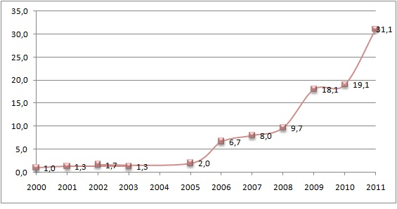
Source: Authors.

In the case of the keywords, 225 papers of the sample presented them, which is a very significant amount (75.3%), especially because some conferences do not demand its use. The presence of key terms is essential for searching by both the websites of the conferences and by search engines on the Internet in general. Concerning the ten most commonly used terms, we recorded that the word "Internet" was placed 65 times in the abstracts, making it the most frequent term. Next comes the word "cyberspace" used 18 times; "electronic government", 14 times; "blog", 12 times; "communication" and "cyberdemocracy", 11 times each; "Internet and Politics" ten times; "politics" and "Twitter" nine times and, finally, the term "social networks" eight times.

INSTITUTIONS AND AUTHORS

With regard to the authors, we analysed variables related to the institutions to which they belong, region and state, education and area of their last degree, as well as if they wrote as co-authors and if they belonged to any research group. The seven most represented institutions in our database were:

Chart 2
Leading institutions
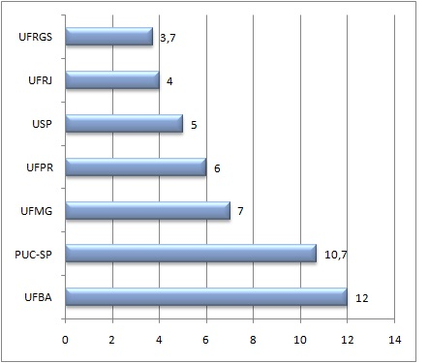
Source: Authors.

From Chart 2, one can see that the institutions that lead the publication of papers correspond to UFBA (12.0%), followed by PUC-SP (10.7%), UFMG (7.0%) and UFPR (6,0%). Together, the seven institutions represent almost half of the total sample (48.4%), there being a perceptible concentration of the researches on south and southeast regions. UFBA (in the Northeast of Brazil) is the exception. We believe its leadership is probably related to the fact that it has one of the oldest programs of postgraduation in the area of Communication in Brazil and because of its precursors researches in Political Communication and Cyberculture.
Besides the analysis by institution, we also evaluated the profile of publication by states in Brazil. Chart 3 shows the ten leading states:

CHART 3
States

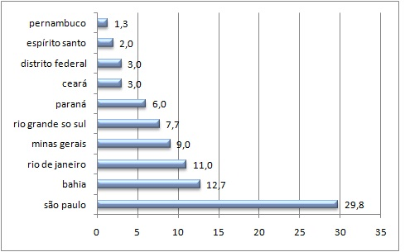
Source: Authors.

Indeed, the Southeastern region is predominant with a significant concentration of publication (51.8%) and this is not due to the work of only one university. The Southern region is in second place (13.7%), but well below the Southeast. In what refers to Bahia's prominent place, it's possible to establish a close relationship between its placement and the publication of UFBA.
We identified 282 distinct authors in the 299 papers of our sample. Regarding the authorship of the papers, a considerable amount was written by only one author (66.2%), representing more than half of the sample. Although a considerable part was made in co-authorship (33.8%), a very modest amount made a partnership between institutions (8%). Of the papers with only one author, more than half states being part of a research group (57.5%). However, several authors did not specify whether they participated or not in groups.
With regard to the title of the author, in Chart 4 one can see a concentration of authors with a high level of education: P.H.D.s (35.5%), followed by Master's students (27.8%) and doctoral students (20.1%). The longitudinal graph showed that there was no significant variation in education and therefore was not included.

Chart 4
Education
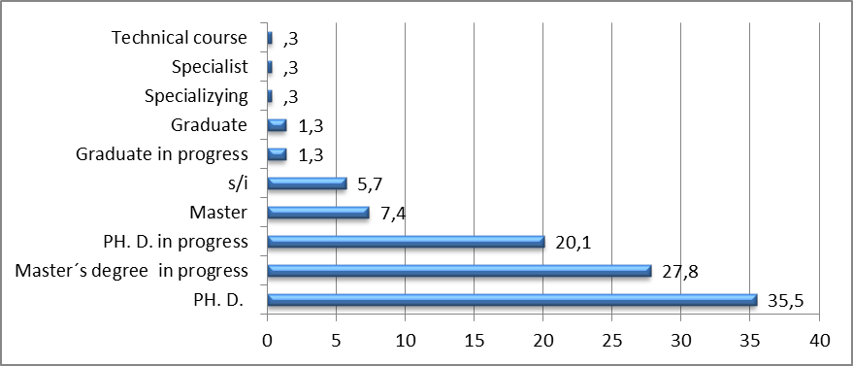
Source: Authors.

In regards to the area of the researchers' most recent degree, we notice a concentration of authors in the areas of Communication (43.5%) and Political Science (17.1%). If we add these areas to Sociology (9.7%), there is a concentration of almost 80% of the sample. These data show that a significant proportion of researchers participate in conferences pertaining to their areas of academic education and that the conferences analysed tend not to be interdisciplinary.

CHART 5
Area of education
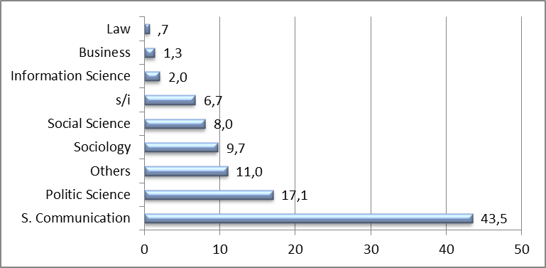
Source: Authors.

We accounted that the first twenty authors presented an average of four papers in the period analysed, representing 28% of the sample. It is a significant concentration if we consider that the average total publication of the rest of the researchers is one paper.

STRANDS, APPROACHES AND OBJECTS

Regard ing information about the type of strand of the papers, we find the majority of them located in the social strand (56.5%). By crossing the type of strand and the conferences (Table 1), those conferences related to the areas of Politics and Sociology (Anpocs, ABCP, Compolitica, Fórum Brasileiro de Ciência Política) favoured the institutional papers. Yet this does not become a rule, since other conferences belonging to the same areas (Seminário Nacional de Ciência Política, Seminário Sociologia & Política, CBS) had more papers from the social strand. However, in the conferences related to the Communication area (ABCiber, Compós and Intercom) a significant number of papers from the social strand prevail.
Table 1 also shows the relationship between the strands and the leading academic institutions. Most notable are UFBA and UFPR with majority of the papers belonging to the institutional strand. On the other hand, UFMG, UFRJ and USP showed research that was significantly more focused on the social strand. Possibly, this is explained by research areas and groups related more to one strand than the other.

Table 1
Conferences, academic institutions and types of strand

 | Social |  | Institutional |  | Total
 | N | % | N | % | N | %
Conferences
Abciber | 25 | 59,5 | 17 | 40,5 | 42 | 100
Anpocs | 13 | 48,1 | 14 | 51,9 | 27 | 100
ABCP | 4 | 30,8 | 9 | 69,2 | 13 | 100
Compolitica | 23 | 44,2 | 29 | 53,8 | 52 | 100
Compós | 22 | 61,1 | 14 | 38,9 | 36 | 100
Intercom | 45 | 77,6 | 13 | 22,4 | 58 | 100
Fórum brasileiro de ciência política | 1 | 20,0 | 4 | 80,0 | 5 | 100
SBS | 5 | 55,6 | 4 | 44,4 | 9 | 100
Seminário nacional de ciência política | 8 | 57,1 | 6 | 42,9 | 14 | 100
Seminário Sociologia e Política | 14 | 58,3 | 10 | 41,7 | 24 | 100
Wapor | 9 | 47,4 | 10 | 52,6 | 19 | 100
Total | 169 | 56,5 | 130 | 43,5 | 299 | 100
Institutions
UFBA | 15 | 40,5 | 22 | 59,5 | 37 | 100
PUC-SP | 18 | 58,1 | 13 | 41,9 | 31 | 100
UFPR | 5 | 27,8 | 13 | 72,2 | 18 | 100
UFMG | 14 | 66,7 | 7 | 33,3 | 21 | 100
USP | 10 | 66,7 | 5 | 33,3 | 15 | 100
UFRJ | 10 | 83,3 | 2 | 16,7 | 12 | 100
UFRGS | 6 | 54,5 | 5 | 45,5 | 11 | 100
Total | 78 | 53,8 | 67 | 46,2 | 145 | 100

Source: Authors.

Chart 6 provides information on the theoretical approaches. One can see that "participation" category (20.7%) was the most recurrent and that "engagement" came in second (12%), which reveals the intention of researchers to understand to what extent the Internet can provide new ways and new channels for the citizen to engage in political processes. The category of "representation" (0.7%) was the least used. Again, the longitudinal graph indicated similar growth between the areas and was not included.

Chart 6
Theoretical approaches
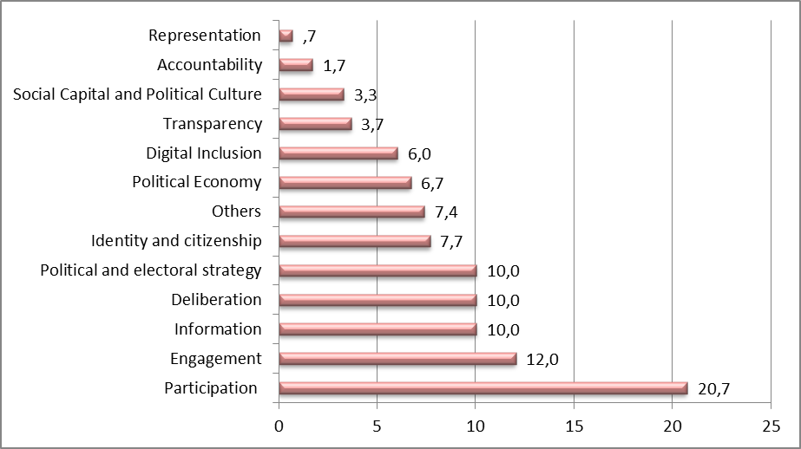
Source: Authors.

It is remarkable to indicate that the main theoretical approaches can be characterized as part of digital democracy field (Gomes, 2007). If we add the categories `participation`, `engagement` and `deliberation` the results are over 40% of our sample. Other approaches that generally are prominent in international studies, such as political strategy, elections, digital inclusion and political economy, have reached relatively small values in our sample
However, we need to weight two things about participation overrepresentation. Firstly, there are studies that deal with political participation in the democratic theory while others deal with more “abstract” concepts of participation based on Cyberculture. Although they are different, both were classified as “participation” – something that other researchers can try to differentiate in future researches. Nevertheless we believe that the participation category would still be the most present, because, mainly, of Brazilian recent history of fight against dictatorship, the even more recent redemocratization process and all related concerns with the insertion of civil society in decision making processes, which emphasizes the role of political participation in democratic processes.
Chart 7 shows information about the political objects. The category "non-organized civil sphere" was the one that showed the maximum value (27.1%) - however, "government" presents a small difference (25.1%). One can notice a preponderance of studies related to spontaneous manifestations of the society and of researches that involve issues close to the executive, legislative and judiciary. The longitudinal study revealed no significant difference in growth between the political objects and was not included. Similar results were found in the work of Medaglia (2012) about researches on e-participation.
The actions of civil sphere (organized or not) represents more than 44% of our corpus. It could be connected to a more “basistic” notion of democracy; therefore the hopes for democratic improvements are deposited in social movements. In this vision the State is an agent to be beaten or even conquered (Gomes, 2007). Future studies can check the reason for this focus on social institutions. Longitudinal analyses have not revealed significant differences and were not included.
We can also highlight the low value achieved by researches regarding political parties (2%), what confirms the impression of Albuquerque & Martins (2010) about the low interest of Brazilian researchers in the relation between political parties and ICTs.

Chart 7
Political object
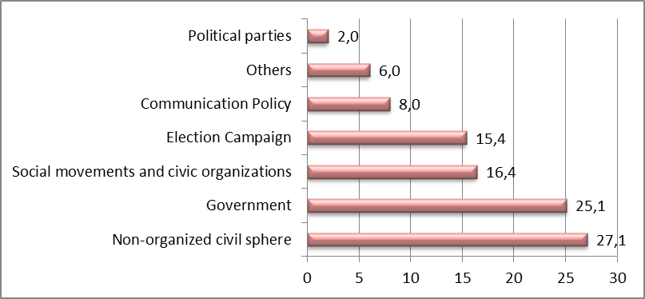
Source: Authors.

Regarding the technological objects, as can be seen in Chart 8, the broader technological categories were the most frequent with 35.8% of the papers reflecting about the "Internet" (in a general way) and other 28.8% about "websites". Together they represent over 64% of the sample. In turn, the technological objects of “web 2.0” (blogs, wikis and social networks) represent still only 24.5% of the corpus – if combined.

Chart 8
Technological object
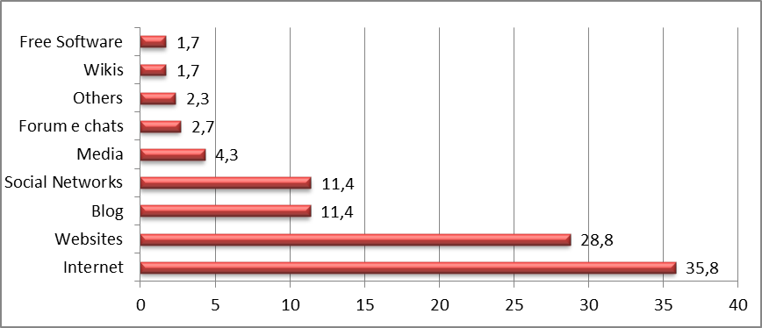
Source: Authors.

However, after the longitudinal analysis, one can see that the category “internet” was the most studied until the year 2003. Thereafter, one can see that other platforms become more noteworthy, such as studies on websites. In 2006, started to appear studies on blogs and social networks (Facebook, Twitter), with a significant growth until 2011. Then, we can affirm that Brazilian research was able to keep up with technological evolution and there is an indication that new technological platforms (e.g. social media) are going to be remarkable in Brazilian academic research.

Chart 9
Technological object per year
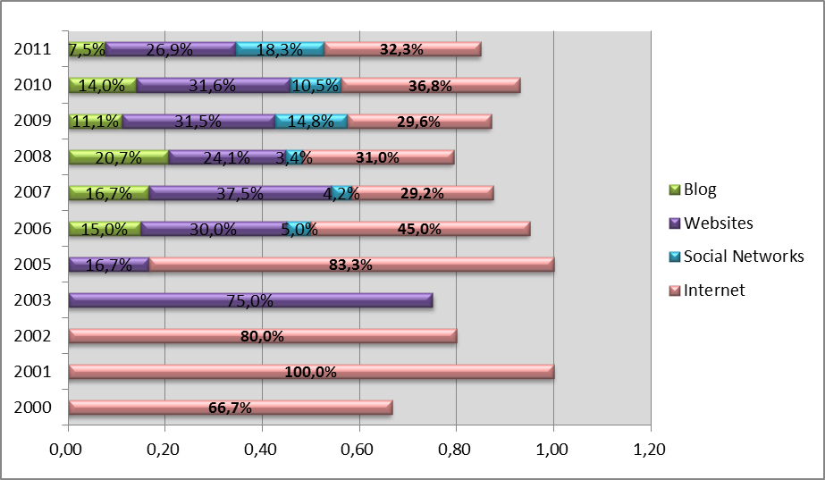
Source: Authors.

METHODOLOGICAL VARIABLES

In what refers to the methodological variables, a majority of empirical studies can be observed (65.9%). In Chart 10, if we compare the types of studies, one can notice that the empirical studies have become more frequent since 2007 and that the theoretical papers are decreasing. Specifically, there is a noticeable difference in 2011 between the studies of empirical (78.5%) and theoretical (21.5%) nature.
Chart 10
Type of study per year
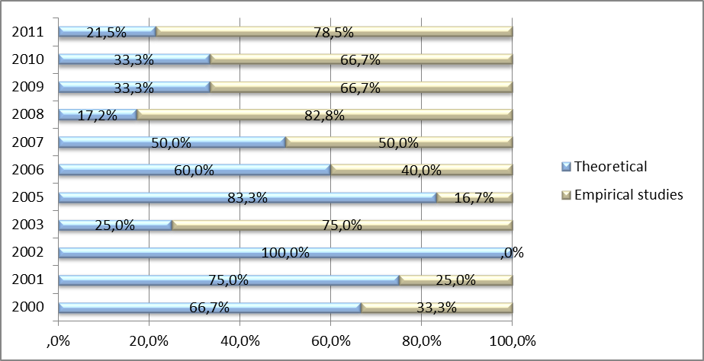
Source: Authors.

Regarding the type of method used, a considerable amount of papers were of a qualitative nature (40.5%), followed by bibliographical papers (33.1%) and, finally, quantitative papers (26.4%). A small percentage applied some kind of statistic (27.8%), in contrast to the 216 papers that did not apply any kind, representing more than 70% of the sample. Of the 83 paper that used statistics, we highlight the preponderance of simple frequency (69.9%), followed by the use of descriptive statistics (22.9%) and only a small use of inferential statistics (7.2%).
However, according to chart 11, the use of statistics has been increasing in the last years. One can specially verify a remarkable raise in the use of descriptive statics from 2007 on and of inferential statics from 2010 on (although its utilization is still low – 25 papers of 83).

Chart 11
Type of empirical technique
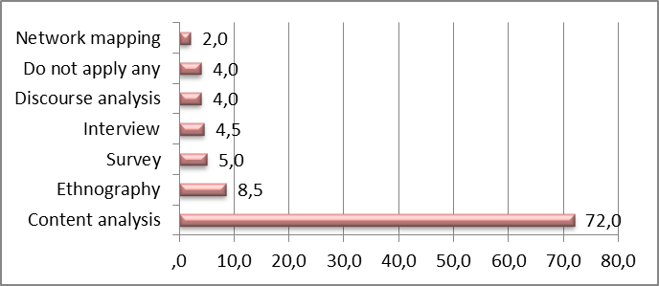
Source: Authors.

Moreover, according to graph 12, a relevant number of papers have employed “content analyses” (72%). If there should be an “ecology” of available techniques, since distinct objects and approaches require distinct techniques, it is worrisome both the concentration of “content analysis” and the relatively absence of other techniques. We do not desire to defend that some techniques lead to the best researches, but we note that there are few techniques being used in Brazilian Internet and Politics field after all. Future studies could try to understand whether this fact is related to research choices or whether if related to some techniques not to be available for most researchers.

Chart 12
Type of statistical technique
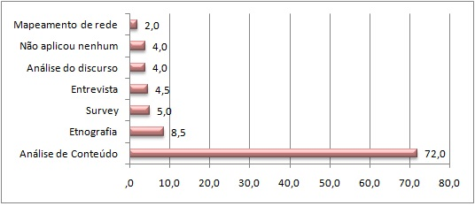
Source: Authors.

CONCLUSIONS

This research has some limitations. Firstly, we opted for classifying the articles using their “emphasis”, what can lead to some distortions. Some articles can have more than one theorical approach or even use two empirical techniques. Nevertheless, we believe that our option allows not only statistical analysis but also effectively highlights the emphasis of the studies.
The second limitation is related to the lack of explanations of the results. Several findings were presented but we did not question the causes for them. Our main objective was mapping the field, something that was not available . We believe that now other researchers can focus on those findings and try to understand their causes and explanations.
Thirdly, we tried to deal with the whole available bibliography, but certainly some articles were not found, something that can be attributed to the poor quality of the congress and associations websites, that often does not have even a searching engine. Still we believe that the corpus is very close to the whole bibliography in Brazilian`s field.
Finally, we believe that future studies could replicate or use a similar approach to the whole Latin America bibliography to assess the difference and similarities among the countries. In this specific case the comparative approach could even be used together with data of each country, such as inhabitants, GDP, internet penetration and level of education, what could provide fruitful correlations. On the other hand one must be extra careful with the differences between the countries, especially in academic terms. For example, Brazil probably has one of the highest numbers of the researchers in the region, but Argentina and Chile are more likely to have more researchers for each 100 inhabitants.
In general, this research indicates numerous disparities and concentrations, especially regarding the authors. The sample points to a concentration of research in leading institutions (UFBA, PUC-SP, UFMG, UFPR), of academic publication in the southeastern and southern Brazil and of the researchers themselves, which can be demonstrated both by the fact that the 20 first authors represent alone almost one third of the sample (28%) and for existing 282 different authors, which indicates that a significant proportion accomplished only one research in the area. The study also points out that there seems to be little interest in changing this situation, since only 8% of the researches represented institutional partnerships. Regarding the study area, it is noted that almost half of the sample belongs to Social Communication (43,5%), which represents almost two times the next two areas, Political Science (17.1%) and Sociology (9.7%).
In relation to the strands (Gomes, 2007), there was a slight preponderance of the social strand (56.5%) over the institutional (43.5%), which is probably connected with the fact that the area of Communication privileged this branch of study (since there was a greater balance between Political Science and Sociology).
In turn, the technological object was the one that suffered the most change over time. The Brazilian researchers initially focused on major questions and research on the subject "Internet". Over time, more specific objects began to be addressed and, recently, blogs and social networks had gained prominence in relation to traditional objects, such as websites.
On the methodological variables, we find that our sample is composed of 65.9% of empirical studies, but there was great variation from 2000 to 2011. Initially, there was a preponderance of theoretical papers and, currently, the majority focuses on empirical studies. On the other hand it is still noticeable that few apply any statistical technique (27.8%) and among these, the majority (69.9%) applies only simple frequency. Only 7.2% used techniques of inferential statistics, showing that there is still little investment in more sophisticated techniques.
Along the text, we indicated some possibilities for future researches. For example, the concentration of researches in southeast and south regions can be related either to a greater number of researchers in these regions or by the presence of some prominent researchers in some institutions. Moreover, our mapping indicates that Brazilian Internet and Politics field has paid more attention to issues related to digital democracy and civil sphere.
Finally, one can see that certain methodologies are still underused by Brazilian researches and a survey could understand better the reasons. There is still the possibilility of future studies analyze the published articles in the Brazilian journals of Social Communication, Political Sciences and Sociology, what would allow both to verify our findings and to compare the differences between initial papers (congresses) and final articles (journals).
Overall, research on "Internet and Politics" in Brazil is growing significantly. On the one hand, such growth is shown with various concentrations and disparities in relation to authors, institutions, states and areas of study. On the other hand, the research indicates a greater consolidation of the field. First, because there is a significant tendency to empirical studies, which demonstrates that the area has already left behind the moment of pure reflection to effectively analyse and verify the different objects, uses and promoters of digital initiatives, as well as possible effects and consequences. And, second, the analysis stopped focusing on broad objects and started evaluating the large number of channels, tools and devices available on the Internet.

REFERENCES

Aggio, C. (2010). Campanhas Online: O percurso de formação das questões, problemas e configurações a partir da literatura produzida entre 1992 e 2009. Opinião Pública, 16(2), 426-445. http://dx.doi.org/10.1590/S0104-62762010000200006.

Albuquerque, A. & Martins, A. F. (2010). Apontamentos para um modelo de análise dos partidos na Web. Paper presented at XIX encontro da Compós, Rio de Janeiro, Brazil. Retrieved from: http://compos.com.puc-rio.br/media/gt3_afonso_de_albuquerque_adriana_figueirola_martins.pdf.

Amaral, A. & Montardo, S. P. (2011). Pesquisa em Cibercultura: análise da produção brasileira da Intercom. Logos, 34 (1), 102-116. Retrieved from
http://www.logos.uerj.br/PDFS/34/08_logos34_montardo_amaral_pesquisa.pdf.

Araújo, W. F. (2011). Ciberativismo: levantamento do estado da arte na pesquisa no Brasil. Paper presented at V Simpósio Nacional ABCiber , Florianópolis, Brazil. Retrieved from http://150.162.39.1/simposio2011/index.php/simposio2011/2011/paper/view/193.

Bimber, B. & Davis, R. (2003). Campaigning Online. The Internet in U.S. Elections. Retrieved from: http://ukcatalogue.oup.com/product/9780195151565.do#.UNnmiG9dWSo.

Braga, S. (2007). O papel das TICs na institucionalização das democracias: um estudo sobre a informatização dos órgãos legislativos na América do Sul com destaque para o Brasil. Retrieved from http://bd.camara.gov.br/bd/bitstream/handle/bdcamara/2685/papel_tics_braga.pdf?sequence=4

Braga, S., França, A. S. T. & Nicolás, M. A. (2009). Mecanismos de participação política e “falas cidadãs” nos websites dos candidatos a prefeito nas eleições de outubro 2008 nas regiões sul e sudeste do Brasil. Paper presented at III Congresso da Associação Brasileira de Pesquisadores em Comunicação e Política, São Paulo, Brazil. Retrieved from http://www.compolitica.org/home/wp-content/uploads/2011/01/bragafrancanicolas.pdf.

Bragatto, R. C. & Nicolás, M. A. (2011). A internet como objeto de estudo no Brasil: balanço da literatura e uma agenda de pesquisa. Paper presented at Seminário Nacional de Sociologia & Política, Curitiba, Brazil. Retrieved from http://www.seminariosociologiapolitica.ufpr.br/anais2011/5_200.pdf.

Chadwick, A. (2011). Explaining the Failure of an Online Citizen Engagement Initiative: The Role of Internal Institutional Variables. Journal of Information Technology & Politics, 8, 21-40. http://dx.doi.org/10.1080/19331681.2010.507999.

Chadwick, A. (2006). Internet politics: States, citizens, and new communication technologies. Retrieved from http://ukcatalogue.oup.com/product/9780195177732.do#.UNnpCm9dWSo.

Coleman, S. & Brumler, J. (2009). The internet and democratic citizenship: theory, practice and policy. Retrieved from http://www.cambridge.org/gb/knowledge/isbn/item1170069/?site_locale=en_GB.

Coleman, S. (1999). Can the new media invigorate democracy? The Political Quarterly, 70(1), 16-22. http://dx.doi.org/10.1111/1467-923X.00200.

Dahlberg, L. (2011). Re-constructing digital democracy: An outline of four ‘positions’. New Media & Society, 13(6), 855–872. http://dx.doi.org/10.1177/1461444810389569.

Gomes, W. (2007). Uma Agenda de Pesquisa sobre “Democracia Digital”. Paper presented at IV Jornada de Comunicação e Democracia, Belo Horizonte, Brazil. Retrieved from http://www.compolitica.org/home/wp-content/uploads/2011/01/gt_ip-wilson.pdf.

Gomes, W. (2011). Participação política online: Questões e hipóteses de trabalho. In Maia, R. C. M., Gomes, W. & Marques, F. P. J. A. (Eds.). Internet e Participação Política no Brasil. Retrieved from http://www.editorasulina.com.br/detalhes.php?id=541.

Kræmmergaard, P. & Schlichter, B. R. (2011). A comprehensive literature review of the e-government research field over a decade. Proceedings of tGov Workshop (tGOV11), Brunel University, London. Retrieved from http://www.iseing.org/tgovwebsite/tGovWorkshop2011/CRCPDF/tGOV-16/Paper%2016.pdf.

LEITE, F. B. (2010). Posições e divisões na Ciência Política brasileira contemporânea: explicando sua produção acadêmica. Revista Sociologia & Política, 18 (37), 149-182. http://dx.doi.org/10.1590/S0104-44782010000300011.

Maia, R. C. M. (2006). Mídia e vida pública: modos de abordagem. In Maia, R. C. M. & Castro, M. C. P. S. (Eds.). Mídia, Esfera Pública e Identidades Coletivas. Retrieved from http://www.editoraufmg.com.br/carrinho.asp?codigo_produto=815.

Maia, R. C. M. (2011). Sob a perspectiva da esfera civil: participação política e internet. In Maia, R. C. M., Gomes, W. & Marques, F. P. J. A. (Eds.). Internet e Participação Política no Brasil. Retrieved from http://www.editorasulina.com.br/detalhes.php?id=541.

Marques, F. P. J. A. (2010). Government and e participation programs: A study of the challenges faced by institutional projects. First Monday, 15, 1-25. Retrieved from http://firstmonday.org/htbin/cgiwrap/bin/ojs/index.php/fm/article/view/2858/2583.

Medaglia, R. (2012). eParticipation research: Moving characterization forward (2006–2011). Government Information Quaterly, 29(3). http://dx.doi.org/10.1016/j.giq.2012.02.010

Moraes, L., Hämmerli, S., Veiga, L., Vasconcellos, M. M. & Santos, S. R. F. R. (2009). Inclusão digital e conselheiros de saúde: uma política para a redução da desigualdade social no Brasil. Ciência e Saúde Coletiva, 14 (3), 879-888. http://dx.doi.org/10.1590/S1413-81232009000300023.

Penteado, C., Pimentel, M. B. & Araújo, R. (2009). Novas práticas políticas na internet: estudo do Blog Fatos e Dados. Paper presented at III Congresso da Associação Brasileira de Pesquisadores em Comunicação e Política, São Paulo, Brazil. Retrieved from http://www.compolitica.org/home/wp-content/uploads/2011/01/penteado_burgos_araujo.pdf.

Sæbø, Ø., Rose, J., Flak, L.S. (2008). The shape of eParticipation: Characterizing an emerging research area. Government Information Quarterly, 25 (3), 400–428. http://dx.doi.org/10.1016/j.giq.2007.04.007.

Sampaio, R. C., Maia, R. C. M. & Marques, F. P. J. A. (2011). Participation and Deliberation on the Internet: A case study on Digital Participatory Budgeting in Belo Horizonte. Journal of Community Informatics, 7, 1-22. Retrieved from http://ci-journal.net/index.php/ciej/article/view/654/705.

Wright, S. (2006). Electrifying Democracy? 10 Years of Policy and Practice. Parliamentary Affairs, 59 (2), 236–249. http://dx.doi.org/10.1093/pa/gsl002.

We would like to thank the valuable contributions and assessments of Prof. Dr. Sérgio Braga and Prof. Dr. Emerson Cervi in the elaboration of the article.
For a broader discussion on the issues of the social strand, see Coleman & Blumler (2009); Maia (2011).
For a broader discussion on the issues of the institutional strand, see Chadwick (2006); Gomes (2011).
To see more about these 3 hypotheses: Wright, 2006.
Although the conferences are linked to Communication, Political Science and Sociology, we believe that this reference was interesting because they are interdisciplinary conferences and also to check if there is any preponderance among researchers from any of the segments. The areas analyzed were: (I) Communication, (II) Political Science, (III) Sociology, (IV) Social Sciences (V) Information Science, (VI) Administration, (VII) Law, (VIII) Computer Science , (IX) Others.
Resulting from theoretical areas used by authors who address issues of the Internet and politics (Bimber & Davis, 2003; Braga 2007; Gomes, 2007; Chadwick, 2006; Dahlberg, 2011; Maia, 2011; Medaglia, 2012; Sæbø et al, 2008).
There are parades and political demonstrations that are clearly linked to associations, unions and civic groups. We classified as spontaneous demonstrations those that were not explicitly presented as a movement or centralized group of actions, such as the marches against Corruption in Brazil, the Occupy Wall Street movement and the Arab revolutions.
For the categorization in simple frequency, descriptive and inferential statistics, we took as reference the thesis of Leite, 2010.
Some online annals were not available. The Intercom offers all the annals from 2001 to 2011, but the annals of 2004 were organized in a way that made it impossible to locate the papers. Therefore, this year is not in our sample. The ABCP has only the last two conferences (2008 and 2010) available online. Regarding the Brazilian Forum of Political Science (Fórum Brasileiro de Ciência Política – Ufscar), we could find online only the annals from 2011 - with 2010 missing. Finally, we found the online annals of WAPOR only from 2011, which was included because it was held in Brazil. In the case of CBS, the annals were available since 2000, but we only found papers from the years 2005, 2009 and 2011.
Federal University of Bahia (Universidade Federal da Bahia - UFBA); Pontifical Catholic University of São Paulo (Pontifícia Universidade Católica - PUC-SP); Federal University of Minas Gerais (Universidade Federal de Minas Gerais – UFMG); Federal University of Paraná (Universidade Federal do Paraná – UFPR); University of São Paulo (Universidade de São Paulo – USP); Federal University of Rio de Janeiro (Universidade Federal do Rio de Janeiro – UFRJ); Federal University of Rio Grande do Sul (Universidade Federal do Rio Grande do Sul – UFRGS).
It is worth clarifying that we accounted only the institutions of the main author.
São Paulo, Rio Janeiro, Minas Gerais and Espirito Santo.
Rio Grande do Sul, Paraná and Santa Catarina.

